CURICULAM VITAE
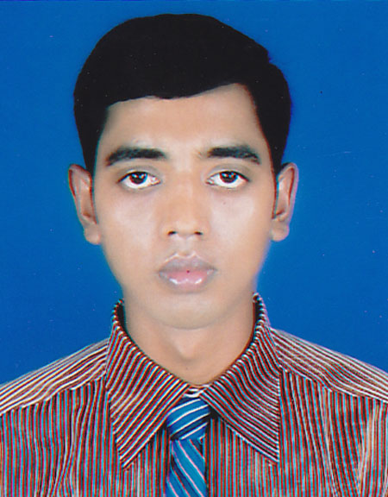

Name
Father's Name
Mother's Name Permanent Address
Present Address
Date of Birth
Religion
Sex
Marital Status
Nationality
Blood Group
Height
Weight
Education Qualification
MD. ABUL KASEM
Enayet Ullah
Nur Banu Begum
Vill-Danershis, P.O-Thanar hat P.S.-Suborno char, Dist-Noakhali.
Vill-Danershis, P.O-Thanar hat P.S.-Suborno char, Dist-Noakhali.
1st April 1991
Islam
Male
Unmarried
Bangladeshi.
A+ (Positive)
5.6”
60 Kgs

Name of Exam | Group | G.PA | Passing Year
s.s.c | Science | 4.13 | 2008
H.S.C | Science | 4.00 | 2010

Computer Skill : MS Word , MS Excel Operating System

Language Skill : I have fluently speaking & writing English & Bengali.

Reference : Salauddin.
Lecturer, Department of Chemistry
Noakhali Govt. College , Noakhali
Mob: +8801819145328

Shawkat Akbar Bhuyain
Lecturer, Department of Chemistry
Noakhali Govt. College , Noakhali
Mob: +8801711129650

------------------------------------
(Md. Abul Kasem)
Applicant Signature

Date :

MD. ABUL KASEM
Date:

